Project Report On
a client/server application using Linux TCP sockets
By

Varun Jose Madanu
NetID - 001617451

Table of Contents

System Documentation 3
High-level data flow diagram 3
Routines 4-5
Implementation 6
Test Documentation 7-13
User Documentation 13

System Documentation

A High-level data flow diagram
The below data flow diagram shows the flow of data in between the server and client and their operation.

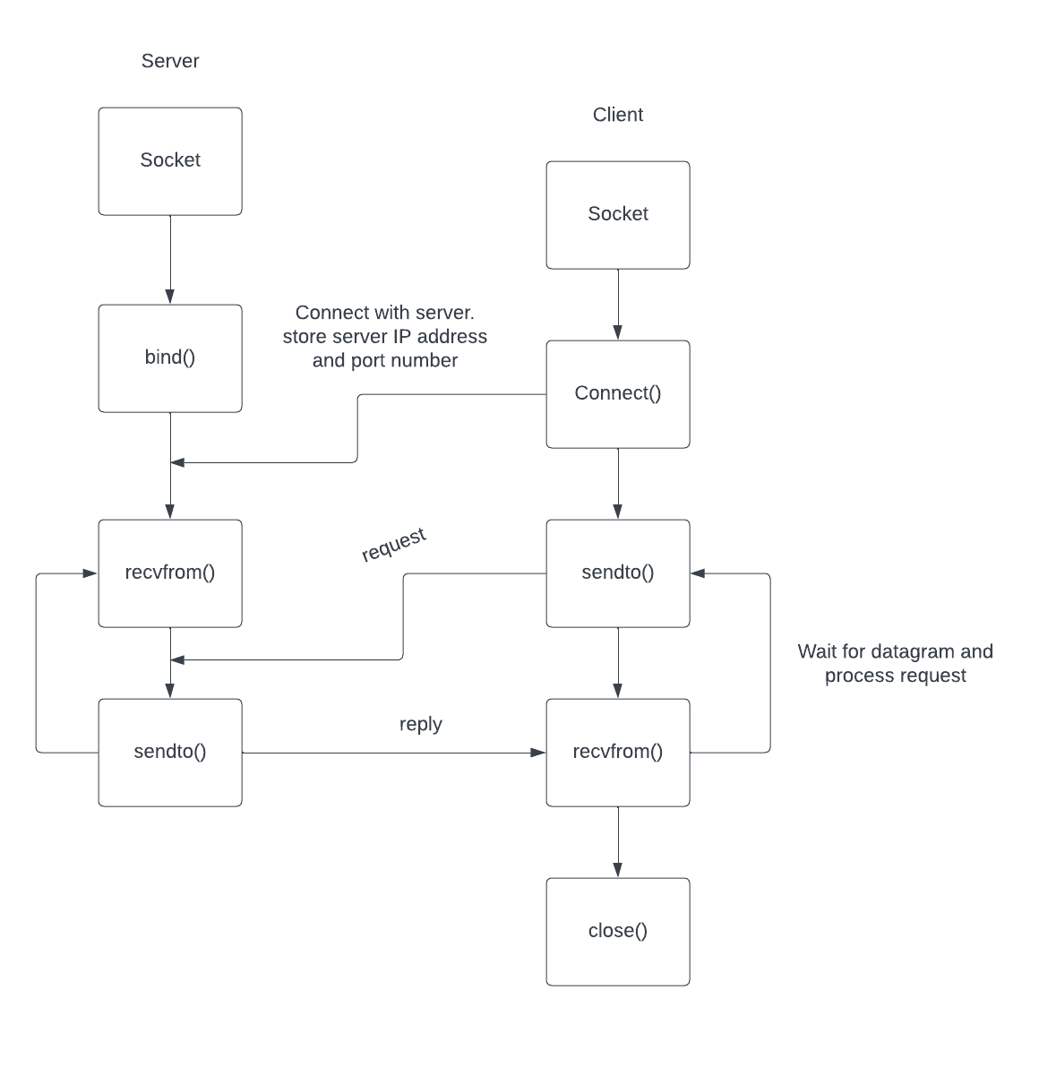

List of Routines Used

server.c
The server creates a listening socket, accepts connection requests, maintains communication with several clients, and works out the logic of the chat program.
client.c
The client side involves the connection of the network to the server to facilitate user interaction and send-receive of messages between the server and network.
handle.h
It provides definitions crucial for a chat application consisting of colour codes for console printing, an enumeration for messaging types, structures for messaging and client interaction details, and utility procedures for string handling and input buffer cleaning. They can be made usable for building a simple chatting program in C language.
crcErrorDetection.c
This program shows how to implement CRC32 for a file with possibly corrected errors. Lastly, they are recorded to an output file ready to be analysed.
hamming.c:
It involves a simple error detection and correction based on hamming code by a 4-bit binary sequence. Given an input file; it computes hamming code, outputs to a second file, introduces an error and then lastly detects and correct errors on hamming coding.
void trim_newline(char *text):
This routine ends with a null terminator so replaces trailing newline characters in a given string, thereby eliminating any newline at the end.
void clear_stdin_buffer(): Finally this routine consumes the rest of characters that are left in the standard input buffer in order to clear up it and not let it affect other users’ inputs in the program.
void initialize_server(connection_info *server_info, int port): Sets up the server’s connection information parameters such as socket and address along with the particular port number.
void send_public_message(connection_info clients[], int sender, char *message_text): Broadcasts public message from the specified sender to all connected clients with the particular message text.
void send_private_message(connection_info clients[], int sender, char *username, char *message_text): Private message that sends the message text from a particular sending user whose name is specified to a particular client, defined by his/her username.
void send_connect_message(connection_info *clients, int sender): A notification of a new client’s connection to all the clients in the network is sent.
void send_disconnect_message(connection_info *clients, char *username): Disconnects the client with the specified username and sends a disconnection message to all clients in order to inform other clients that the particular client has disconnected.
void send_user_list(connection_info *clients, int receiver): Provides a list of all users connected to the designated receiver client.
void send_too_full_message(int socket): Informs the client’s server that the server is fully connected for the additional connection.
void stop_server(connection_info connection[]): Cleans up all the open sockets, closed all the connections and released all associated resources, stopping the server.
void handle_client_message(connection_info clients[], int sender, FILE *file): Deals with messages from clients, both public and private ones.

int construct_fd_set(fd_set *set, connection_info *server_info, connection_info clients[]): Builds a file descriptor set which includes all needed sockets that involve the server socket and other clients sockets.
void handle_new_connection(connection_info *server_info, connection_info clients[]): Accepts a new client connection, handles it, updates the client info.
void handle_user_input(connection_info clients[]): Allows clients to send either public or private messages among other things.
void get_username(char *username): It asks the user to enter his or her username and saves it temporarily inside the `username` character array.
void set_username(connection_info *connection): User inputs and sets client’s username.
void stop_client(connection_info *connection): Ends up a client by means of breaking a connection and releasing related resources.
void connect_to_server(connection_info *connection, char *address, char *port): Uses the specified sever address and port to connect a client to a server.
void handle_user_input(connection_info *connection): Permits sending of messages by a client, or to hang up.
void handle_server_message(connection_info *connection): Receives messages sent by the server and processes the public and the private messages.
void correctError(unsigned char *data, size_t position): Single bit error correction of the data array at an indicated location by reversion of the bit.
void correctError(char *hamming, int errorPos): Flips a single bit in the Hamming code array at a particular location that results in correcting the single-bit error occurring there.

int detectError(char *hamming): Find and restores the position of a single-bit error in Hamming code matrix.
void calculateHammingCode(char *data, char *hamming): Computes a seven bit Hamming code for a four bit data array and stores it into the Hamming code array provided.
Void frameContent():
It adds syn and length of string character frame.
Void deFrame():
This adds to the string character frame’s syn and length, which must be removed here.
Void calculateParity():
It adds an odd parity bit and places it at the most significant bit of the character’s binary string.
void byte_to_binary_with_parity():
To convert from a character stream to binary stream.

Void convertingAsciiToCharacter():
This method is used to convert decimal number to its equivalent character.

Void checkParity():
This method is used to remove the parity bit in every binary stream.

Implementation

The code that has been presented has been divided in three different parts for various uses. Simple Chat Server, consisting of server.c and client.c form the first bit. The server creates a socket, binds it and waits for connection requests. Select-based managing of multiple client. This server support private and public messaging, username handling, notify users’connection, and notification when disconnecting a user. it has also taken into account a user list. However, the client connects to a server, chooses a username, and addresses a server through message sending.
Furthermore, the second part of the code referred to as “crc.c” focuses on data transmission for error detection and correction. This is a program which computes CRC32 checksums for specified data. It creates an artificial error that simulates how the data would be sent and then tries to determine and rectify the error. It prints the error detected position and if any error is found, then it corrects it and prints the corrected data.
Finally, the last segment of this code, `hamming.c` imples Hamming code. Program which reads the data from the inputfile converts it to binary, applies the hamming code on every nibble of four bits of data and then writes the coded data in the outputfile. Thereafter it decodes the encoded data, corrects the errors using the Hamming code before printing out the detected and corrected errors.
To summarize, the chat server allows for communication among different clients, the CRC code emulates the error detection and correction that take place during data transmission, and the Hamming code software encodes and decodes information that is able to detect and correct errors.

Testing
- The outputs of each phase are written in files naming – ‘result.txt’, ‘resultcrc.txt’, ‘history.txt’.
- Testing outputs:
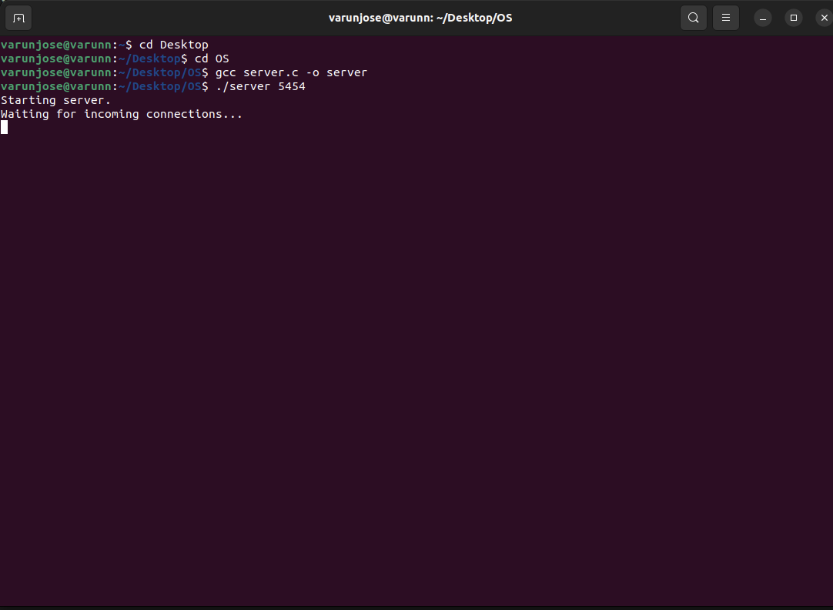

Fig: Server connected
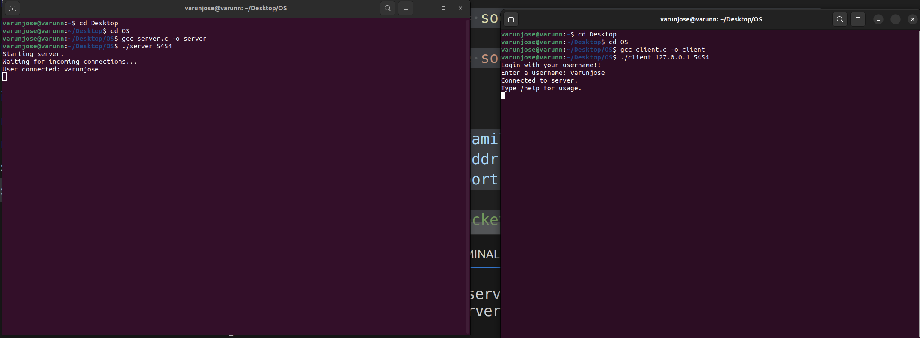
Fig : Client logged in
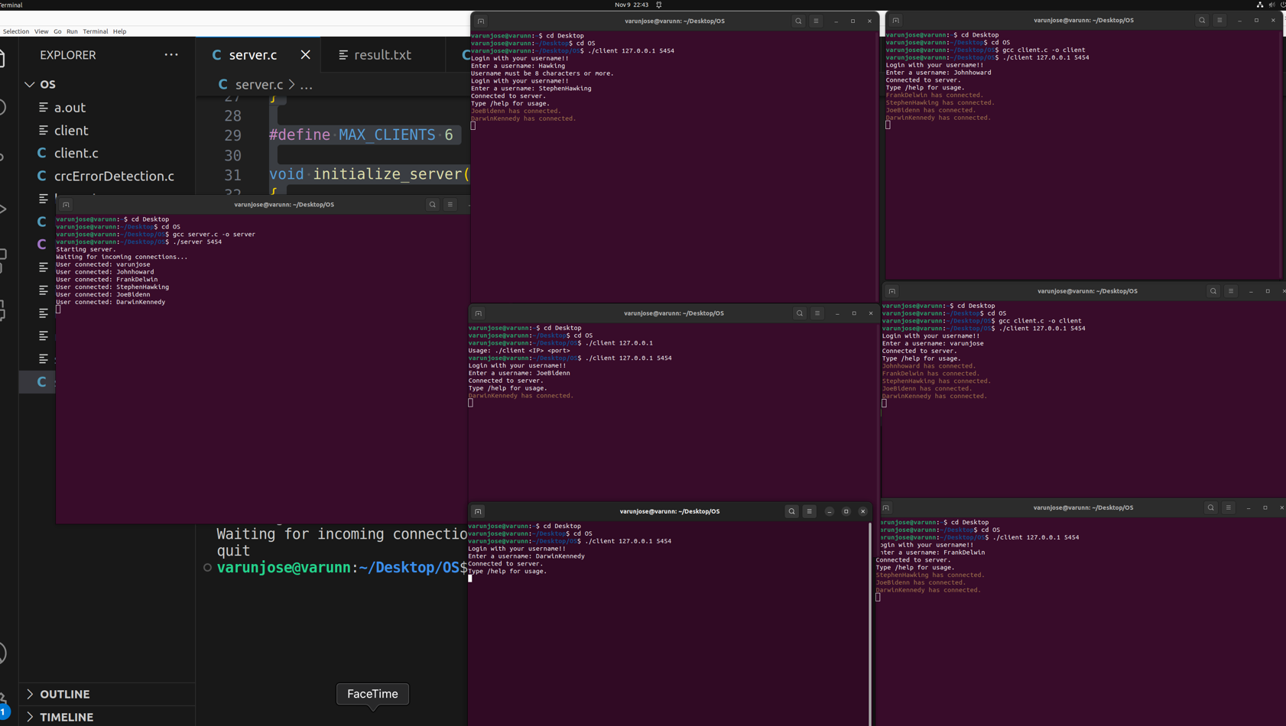

Fig: Six Clients connected to the server

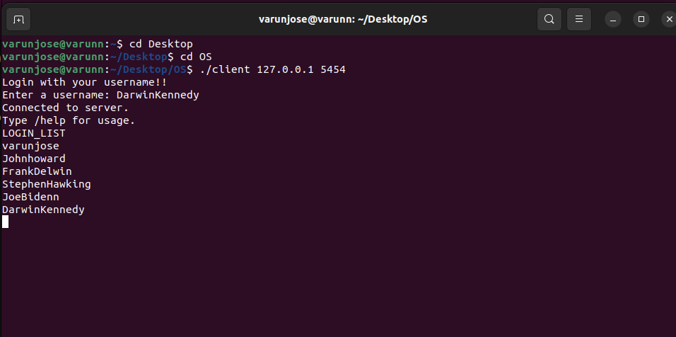
Fig-LOGIN_LIST

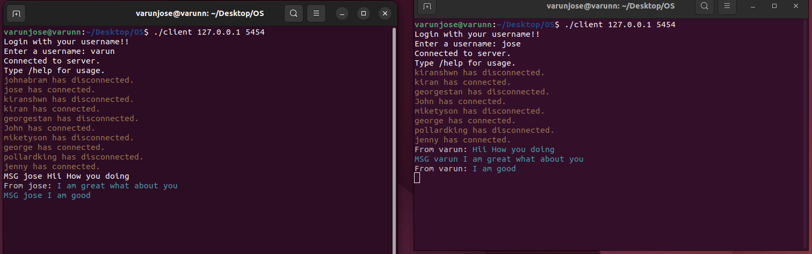
Fig:Client chatting one-to-one
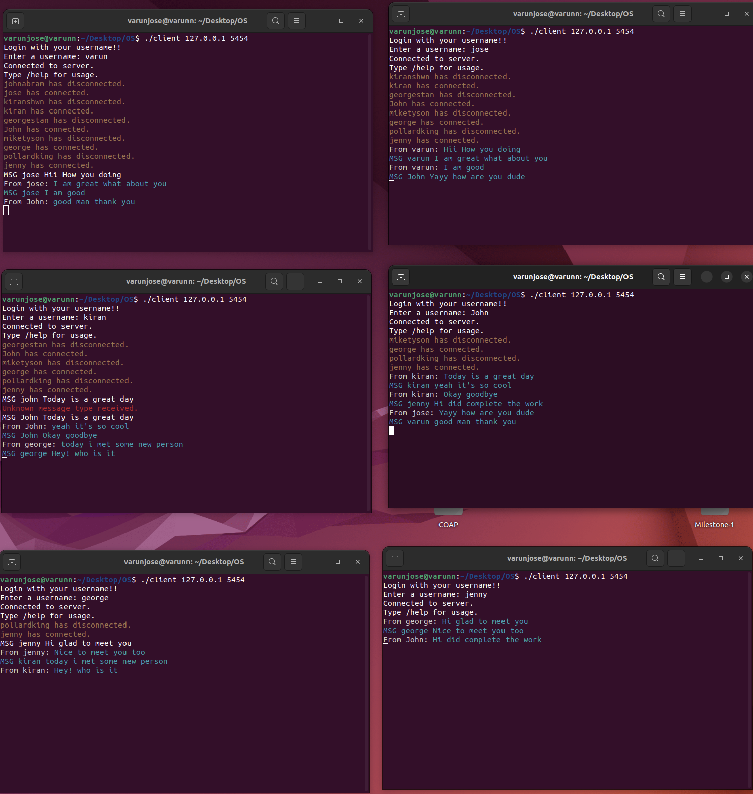
Fig:Six clients chat eachother

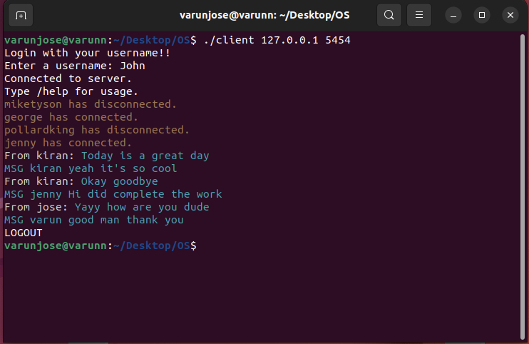
Fig:Client logged out

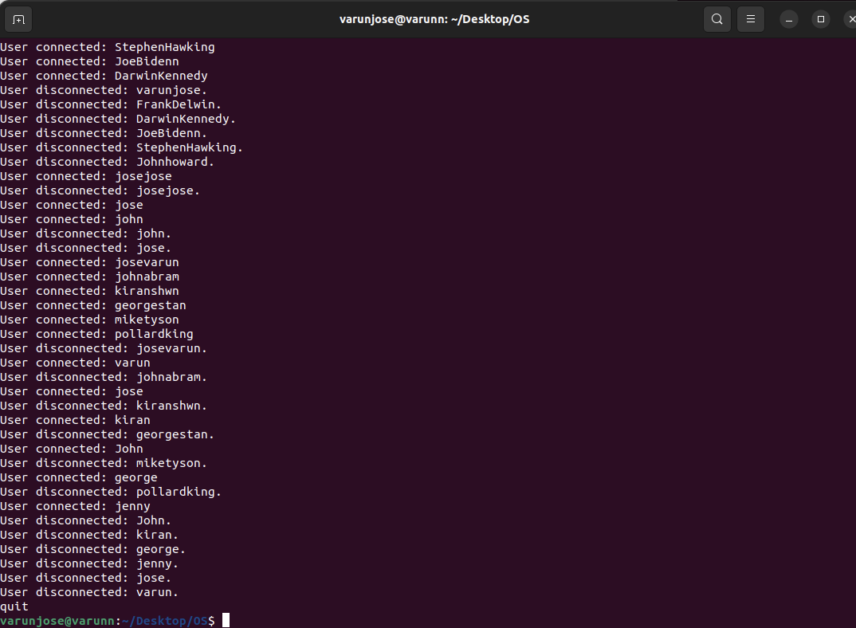

Fig: Server disconnected

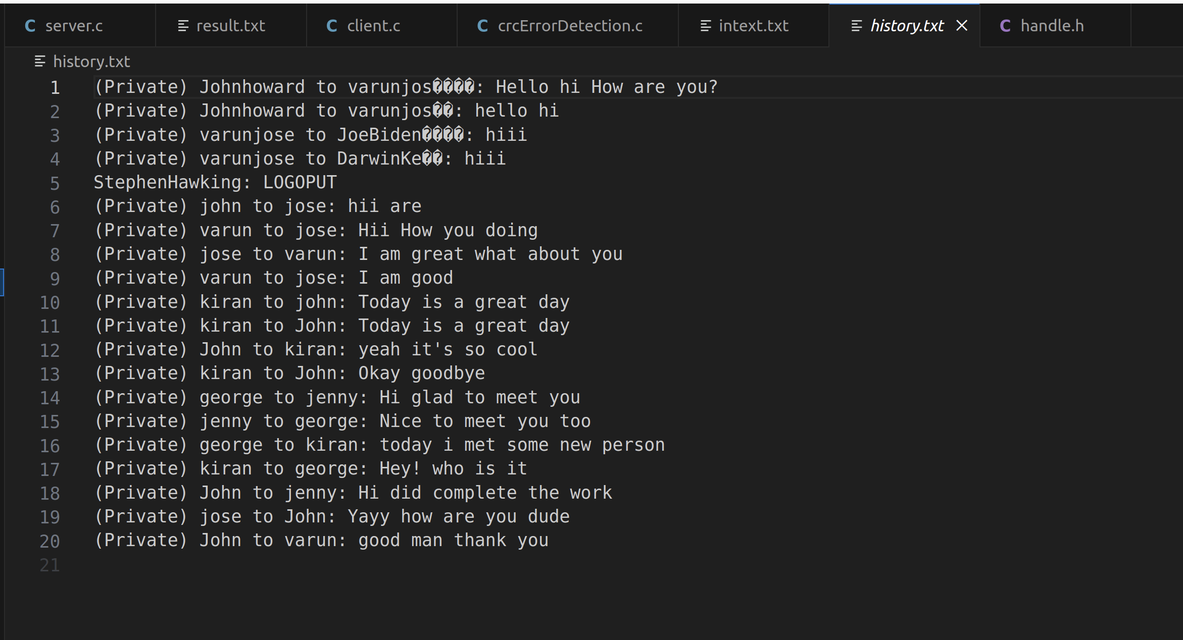

Fig: Chat History

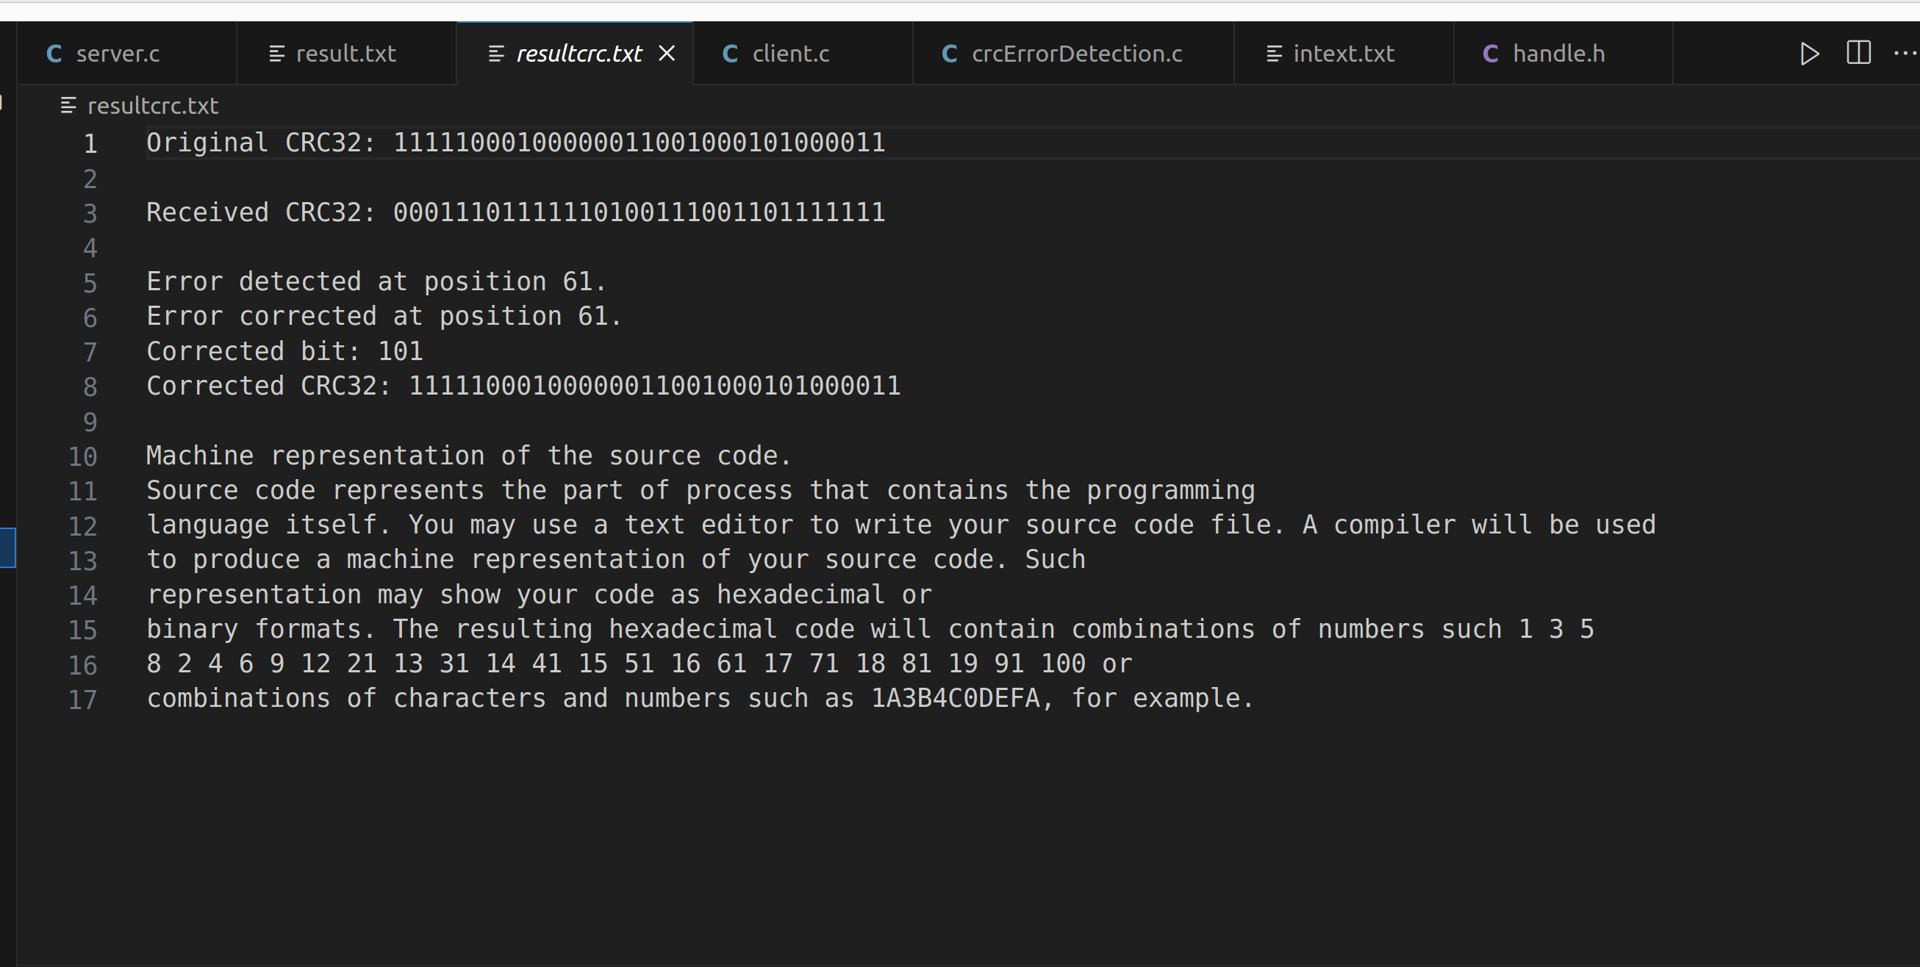
Fig: crc error detection and correction
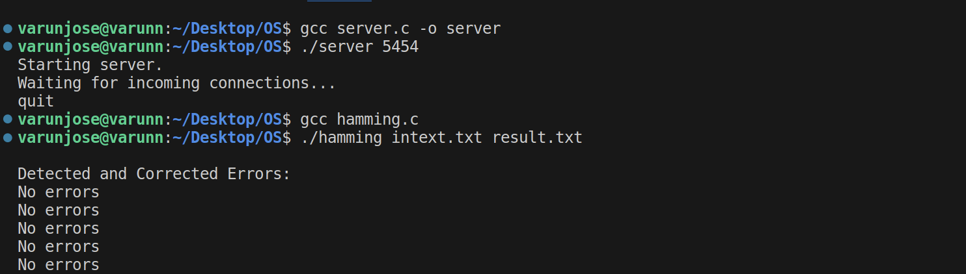

Fig: Performing Hamming

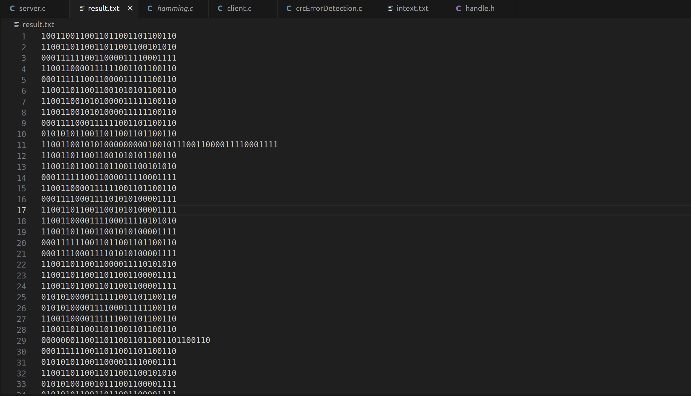

Fig: Result of hamming code

User Documentation

The source files are all present in my code files.

Execution of program:
- In order to run the program in Linux, we need to open the terminal.
- Firstly, connect to the server:
  - Do compiling “gcc server.c -o server”
  - Now run the program “./server 9898”
- Now connect to number of clients required
  - Do compiling “gcc client.c -o client”
  - Now run the client program to connect server ”./client 127.0.0.1 9898”
- Later compile crcErrorDetection.c as “gcc crcErrorDetection.c”
  - And run “./a.out”
- Perform hamming “gcc hamming.c -o hamming”
  - Then run “./hamming <input file> <output file>”

- Describe any parameters:
  - In client console, type LOGIN_LIST to view total number of clients.
  - Type MSG <username> <message> to send private message.
  - Type LOGOUT to disconnect from the server.
  - Type “/help” to get info of how chat application works.

